**Student Activity Guide: Understanding Color** Name: ________________________

Unit 1 Lesson 11

**Scenario**

In your role as a computer scientist on a team at NASA, you have been presented with a new challenge. Colors in any images that are intended to be displayed in electronic format must be mixed with an “additive” color mixing strategy. Your task is to learn how this technique is different from mixing colors for “print” images. Your computer science knowledge about binary and hex numbers is going to help you a great deal!

**Directions**

Use the [Pixelation tool v.3](http://bit.ly/pixeltoolv3) *(*[*http://bit.ly/pixeltoolv3*](http://bit.ly/pixeltoolv3)*)*

1. Set bits-per-pixel to 3 and create a 2x4 image that shows all 8 possible colors

.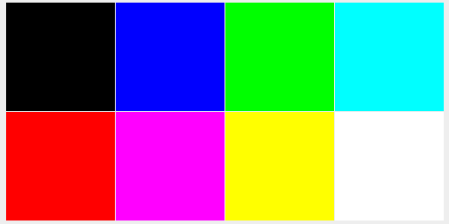

1. Create the following 2x2 image with the bits-per-pixel set to 6.



1. Make a 4x4 image with the bits-per-pixel set to 12. Switch the tool into hex mode and make an image in which the first row displays 4 different “reddish” colors (with red being the dominant color in each pixel). The second row should show 4 different “greenish” colors, the third row should show 4 “bluish” colors, and the fourth row should show only shades of gray. It should look something like this:

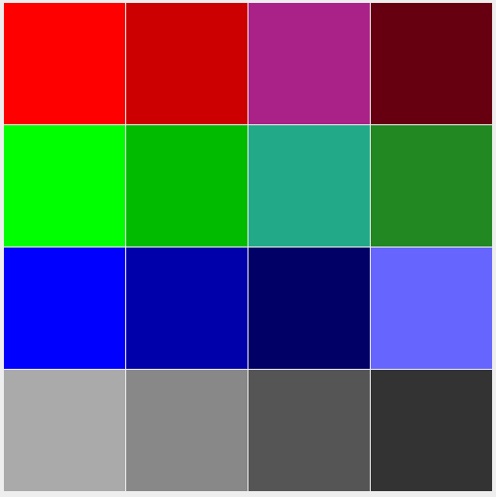

1. Summarize your understanding of “additive colors” and “subtractive colors.” Describe how colors are “mixed” in each method. Be sure to include examples of when each might be encountered in the everyday life of a student.
2. Compare your images with those of another student. Are they the same? Are they different? If they are different, analyze your work and determine where the errors occurred. Why did that error create the image you observed?